|  |
| --- |
| **Design Factors and Objective Prioritisation Report**  Organisation: NWU Assessment: COBIT 2019  Lead Assessor: John Smith Focus Area: General Code Model  Maturity Level: Year: 2023 |

**Statement:**

The corporation manufactures goods, is a large enterprise, is very cost conscious, and desires to be a cost leader in its market. The enterprise considers I&T purely a supporting function for efficient and effective operations. Although IT is a supporting function, the enterprise is critically dependent on it. The enterprise takes a traditional approach to new development and operations and is quite hesitant to adopt new technologies. Recently, the enterprise was confronted with a malware attack and suffered from several operational IT problems. The enterprise houses and operates critical IT equipment in-house.

**Step 1: Understanding the Enterprise Context, Strategy and scope of NWU’s governance system**

* 1. Enterprise Strategy (Design Factor 1)

A primary focus on **Innovation/Differentiation, Growth/Acquisition** and a secondary focus on **client service/stability** is/are depicted as outlined below.

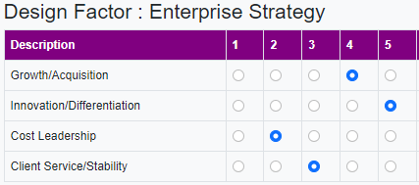

* 1. Enterprise Goals (Design Factor 2)

The enterprise has ranked the 13 generic enterprise goals on a scale from 1 to 5, as depicted below. The diagram shows that **EG03 Compliance with external laws and regulations**, **EG06 Business-service continuity and availability** is/are the highest-ranked enterprise goal/s.

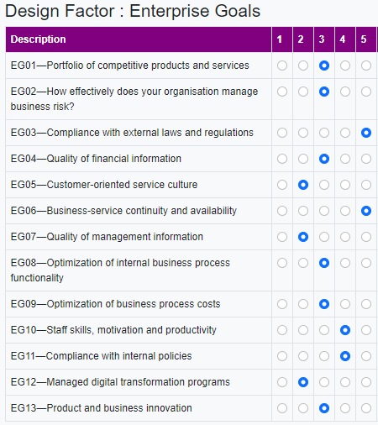

* 1. Risk profile (Design Factor 3)

A high-level risk analysis has resulted in a risk profile, identifying the following highest risk categories: **IT operational infrastructure incidents, unauthorized actions, software adoption/usage problems, hardware incidents, software failures and logical attacks**.

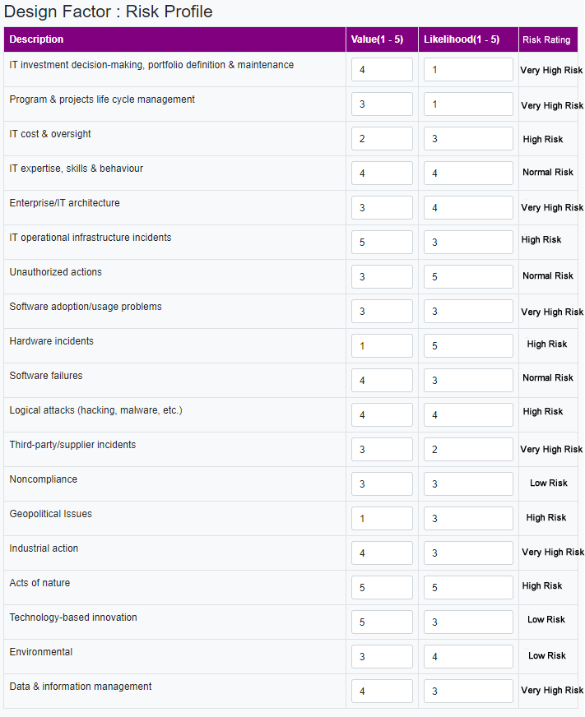

* 1. I&T-related issues (Design Factor 4)

An analysis of the current situation (on a scale from 1 to 3) resulted in an assessment of current I&T-related issues, as depicted below. These are perceived to be important issues to the enterprise: **significant incidents, service delivery problems by outsourcers, hidden IT cost and IT cost overall**.

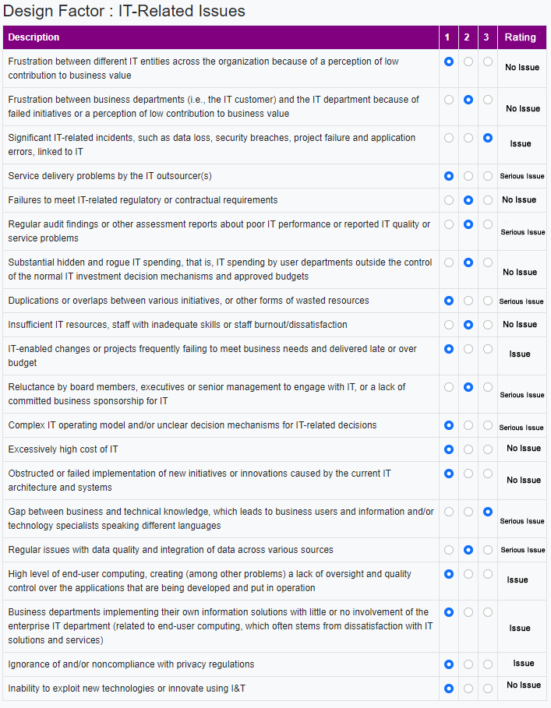

* 1. Threat landscape (Design Factor 5)

The diagram below depicts the threat landscape under which the enterprise believes it operates. D**ue to its geopolitical situation, industry sector or particular profile, the enterprise is operating in a 93% high-threat environment**. In addition, **the enterprise is operating under what are considered normal threat levels at 7%**.

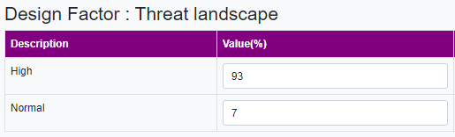

* 1. Compliance requirements (Design Factor 6)

**The enterprise is subject to higher (81%) than average compliance requirements, most often related to industry sector or geopolitical conditions.**

* 1. Role of IT (Design Factor 7)

The role of IT is expressed as **strategic. IT is critical for both running and innovating the organization’s business processes and services.** Secondary IT is expressed as **support. IT is not crucial for the running and continuity of the business process and services, nor for their innovation.**

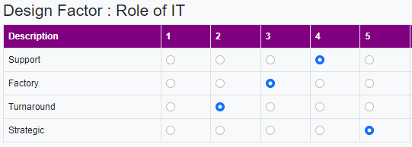

* 1. Sourcing model for IT (Design Factor 8)

The selected sourcing model of the enterprise, is predominantly **insourced** at **65**% **(The enterprise provides for their own IT staff and services).** Secondary is **outsourcing** at **20**% **(The enterprise calls upon the services of a third party to provide IT services)**

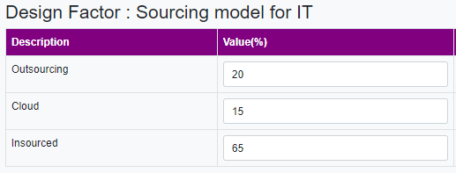

* 1. IT implementation methods (Design Factor 9)

The enterprise primarily uses **traditional** IT development and operations methods at **46**%. **The enterprise uses a more classic approach towards software development (waterfall) and separates software development and operations**. Secondary it uses **devOps** at **34% (The enterprise uses DevOps working methods for software building, deployment and operations)**

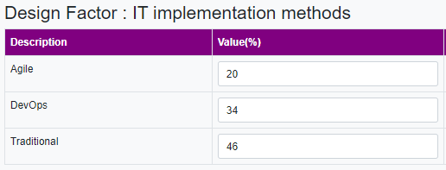

* 1. Technology adoption strategy (Design Factor 10)

The enterprise is, at best, a **first mover** at **40**% when it comes to new technology adoption. The enterprise generally adopts new technologies as early as possible and tries to gain first-mover advantage.

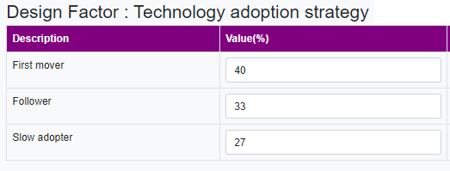

**Step 2: Governance and Management Objectives**

This section adds the governance and management priorities resulting from step 1. This synthesis results in the following adjusted priorities for governance and management objectives in **NWU**’s governance system.

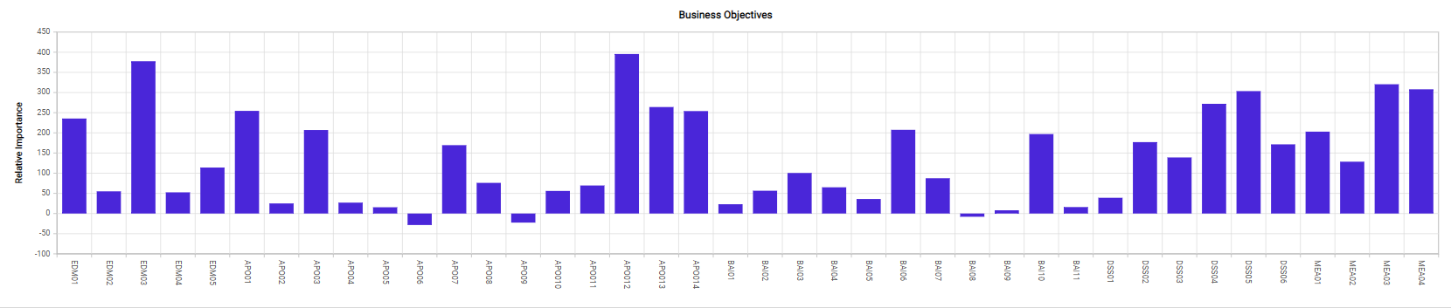

* 1. Important objectives

The following governance or management objectives are likely to be important for the governance system of this enterprise.

* **DSS02 Managed service requests and incidents (100)**
* **APO13 Managed security (80)**
* **DSS04 Managed continuity (80)**
* **DSS03 Managed problems (75)**
* **BAI09 Managed assets (75)**
* **BAI10 Managed configuration (75)**
  1. Least important objectives

The following governance or management objectives are likely to be least important for the governance system of this enterprise.

* **APO04 Managed innovation (-75)**
* **BAI11 Managed projects (-70)**
* **BAI01 Managed programs (-50)**
* **APO02 Managed strategy (-45)**
* **BAI05 Managed organizational change (-45)**
  1. Scope selection of priority objectives

In its discussions, the enterprise has decided to include the following governance and management objectives as priority areas for audit:

|  |  |  |
| --- | --- | --- |
| Reference | Governance/Management Objective | Target Process Capability Level |
| **DSS02** | **Managed service requests and incidents (100)** | 4 |
| **APO13** | **Managed security (80)** | 4 |
| **DSS04** | **Managed continuity (80)** | 4 |
| **APO02** | **Managed strategy (-45)** | 1 |
| **BAI05** | **Managed organizational change (-45)** | 1 |
| * Any governance/management objective that scored 75 or higher—meaning that its importance was at least 75% higher compared to a benchmark situation—would require a capability level 4. * Any governance/management objective that scored 50 or higher would require a capability level 3. * Any governance/management objective that scored 25 or higher would require a capability level 2. * Remaining processes should reach capability level 1 | | |